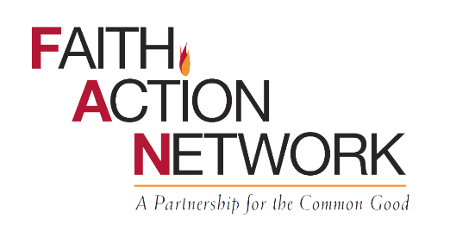
CENSUS EQUITY ACTION DAY:
WE ALL COUNT!

The census takes place once every decade. Spring 2020 is our chance to make sure all people are counted, and to show that all people count!

PLAN A CENSUS EQUITY ACTION DAY

FAN encourages your faith community to plan a Census Equity Action Day sometime between March 12 and April 1 (Census Day). Here are some possible actions you can organize:

- Provide fact sheets on the census to your congregation. FAN has many resources linked on our website at https://fanwa.org/advocacy/advocacy-toolkit/census-2020 that you can download and print, some specific to various faith traditions and in many languages.

- Invite a speaker to talk about the census, its importance, and how to take part. Contact fan@fanwa.org and we will put you in touch with the right people for your area.

- Host a Census Assistance Center/Event to enable others to complete the census by (ask for FAN’s how-to one-pager and training webinar):
  - Set up computers (and phones if possible) in your facility to help people without personal computers or internet access to complete the census online.
  - Help a community outreach program (food bank, community meal, day center) with which your congregation is associated provide opportunities for clients to complete the census. Keep in mind that homeless shelters, hospitals, colleges and prisons will be counted as part of the Census Bureau’s Group Quarters process.
  - Open your building or collaborate with another venue, like a library or community center, to host a census assistance event for the public.

- Highlight the census in a worship service or community event. You can get bulletin insert downloads from FAN’s census toolkit, and find sermon guides, a Litany on Dignity and Justice, and relevant Sacred Texts at https://www.faithinpubliclife.org/censussabbath.

- Find a way to celebrate your progress as households complete the census in your faith community-- have a party!

WHY DOES IT MATTER?

The Census directly affects your political voice in this democracy. Census data help determine how many legislative and Electoral College representatives each state has and how district lines are drawn.
Results from the Census are used to determine what share of $883 billion in federal funding ($16.7 billion to Washington alone) goes to your community for social services like Medicaid, Section 8 housing, Supplemental Nutrition Assistance Program (SNAP), school and transportation funding, and much more.

